Transmart/i2b2 ETL Toolkit

Table of Contents
1. Introduction 2
1.1. Document Outline 2
1.2. Document Description 3
1.2.1. Introduction 3
1.2.2. System Overview 3
2. Design Considerations 4
2.1. Assumptions and Dependencies 4
2.2. General Constraints 4
2.3. Goals and Guidelines 4
2.4. Development Methods 4
3. Architectural Strategies 5
4. System Architecture 5
4.1. OMOP 5
4.2. I2b2/transmart 6
4.3. Ontology 6
4.4. Loading 7
4.5. OMOP to i2b2 7
5. Glossary 7
6. Bibliography 7

Introduction

Currently there is no good ETL tool for i2b2, on the other hand Transmart has a couple of ETL tool that assist in loading data into. The toolkits for Transmart are good at loading trial based data but might not have adequate for loading data from EHR systems. This document will outline the requirements for creating a toolkit that can load data from a EHR, transform it to a common data model, and than load the data into i2b2/tranSMART.

Document Outline

Here is the outline of the proposed template for software design specifications.

- Introduction
- System Overview
- Design Considerations
  - Assumptions and Dependencies
  - General Constraints
  - Goals and Guidelines
  - Development Methods
- Architectural Strategies
  - strategy-1 name or description
  - strategy-2 name or description
  - ...
- System Architecture
  - component-1 name or description
  - component-2 name or description
  - ...
- Policies and Tactics
  - policy/tactic-1 name or description
  - policy/tactic-2 name or description
  - ...
- Detailed System Design
  - module-1 name or description
  - module-2 name or description
  - ...
- Glossary
- Bibliography

Document Description

Here is the description of the contents (by section and subsection) of the proposed template for software design specifications:

Introduction

We are going to create a toolkit using available software that will load data from a HER system into i2b2/transmart

System Overview

Using Microsoft Server Data Tools (SSDT) we will create four packages and three projects within the SSIS platform The projects will be based on each database platform: Sql Server, Oracle and postgresql. The four packages will be
- Loading - This will be a one to one mapping of the EHR system. So if the demographics data is in a table called person, than that exact table will be in the package.
- Work – This will transform the Loading into an OMOP data model
- QA – Using Automated Characterization of Health Information at Large-scale Longitudinal Evidence Systems (ACHILLES), the data loaded into OMOP will be validated (https://github.com/OHDSI/Achilles)
- Ontology – This will load the PCORI or ACT ontology into the database
- Transmart/i2b2 – This will load the OMOP data model into either tranSMART or i2b2

Design Considerations

This section describes many of the issues which need to be addressed or resolved before attempting to devise a complete design solution.

Assumptions and Dependencies

In SSIS, Sql Server by defaults connects without third party tools, but for Oracle, Microsoft Connectors for Oracle and Teradata is needed (https://www.microsoft.com/en-us/download/details.aspx?id=55179). For Postgresql, a ODBC connection will need to be created.

For SSDT, we will be using SSDT for Visual Studio 2019

The development will be done on either Windows 10 or Windows Server on a Amazon Cloud. This will allow for multiple developers to work.

General Constraints

We will be testing using the SynPUF 1000 person dataset on a OMPA CDM 5.2.2. http://www.ltscomputingllc.com/wp-content/uploads/2018/08/synpuf1k_omop_cdm_5.2.2.zip

Development will be done on an Amazon Windows instance, and the developers will connect using Remote Desktop Connection and have a unique username/password. The code will be commited to a GitHub repository (https://github.com/i2b2/i2b2-transmart-etl)

Goals and Guidelines

Development Methods

Most of the development will be done in the Visual Studio SSDT, the instance will have a Sql Server Express loading and the first project will be Sql Server.

Architectural Strategies

TODO.

System Architecture

We need to consider using either OMOP v5 or V6.

OMOP
No single observational data source provides a comprehensive view of the clinical data a patient accumulates while receiving healthcare, and therefore none can be sufficient to meet all expected outcome analysis needs. This explains the need for assessing and analyzing multiple data sources concurrently using a common data standard. This standard is provided by the OMOP Common Data Model (CDM).

The CDM is designed to support the conduct of research to identify and evaluate associations between interventions (drug exposure, procedures, healthcare policy changes etc.) and outcomes caused by these interventions (condition occurrences, procedures, drug exposure etc.). Outcomes can be efficacious (benefit) or adverse (safety risk). Often times, specific patient cohorts (e.g., those taking a certain drug or suffering from a certain disease) may be defined for treatments or outcomes, using clinical events (diagnoses, observations, procedures, etc.) that occur in predefined temporal relationships to each other. The CDM, combined with its standardized content (via the Standardized Vocabularies), will ensure that research methods can be systematically applied to produce meaningfully comparable and reproducible results.
Below is a figure of the datamodel
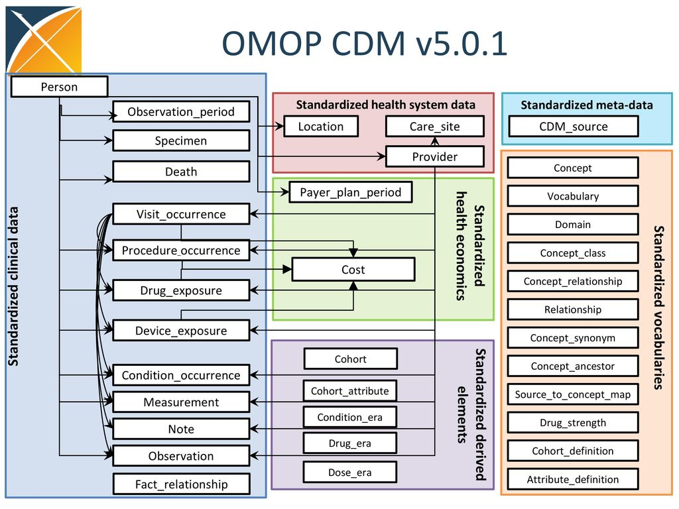

I2b2/transmart
Informatics for Integrating Biology & the Bedside, or i2b2 is an NIH-funded enterprise clinical research platform, which contains a database model, application layer, and core APIs.

tranSMART is a suite of data exploration, visualization, and ETL tools, which were developed by pharma for translational research studies.

The data model is a star schema, where all the clinical data is loaded in the observation_fact table, and the demographics is loaded in the patient_dimension. The demographics can be loaded in the observation_fact, but for this project we will load it into the patient dimension.

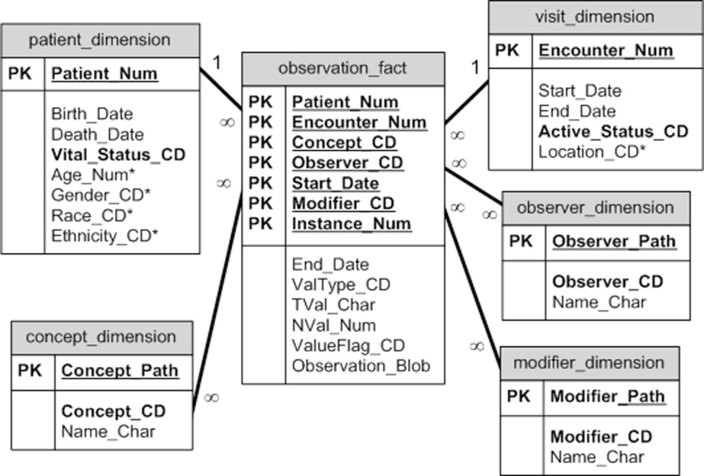

Ontology
There will be two ontologies that can be loaded, one is PCORI and the other is ACT. Flat files will be loaded in either C:\ACT or C:\PCORI and connection managers will be used to load the flat files to specific tables. Below is screenshot of a PCORI Ontology Load

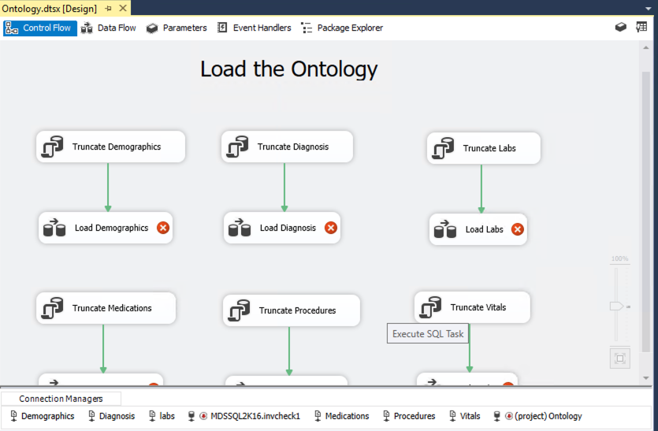

Loading

We will provide a couple of samples EHR loaders, such as All Scripts, Cerner, and EPIC. The EPIC will not be on the github and will be posted on the EPIC forum only due to restrictions on the EPIC data model.

The loading will consist of the following steps:
- Load data from the Data Warehouse and have a one to one mapping
- The mapping of the EHR to OMOP can either be done via stored procedures or via SSIS toolkits
The following is same view of a loader

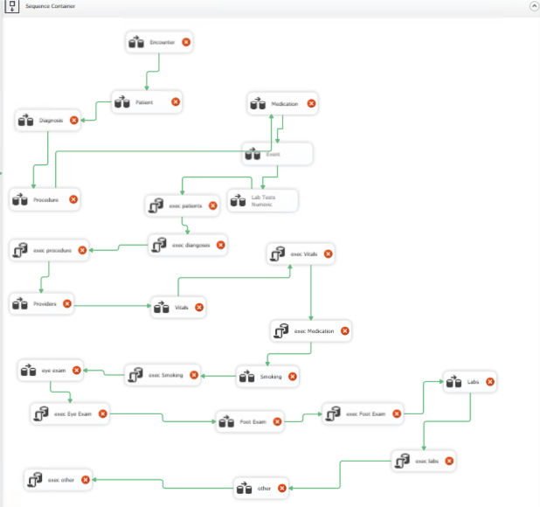

OMOP to i2b2

Using stored procedures develop scripts that will convert OMOP to i2b2

Glossary

Bibliography

